0
1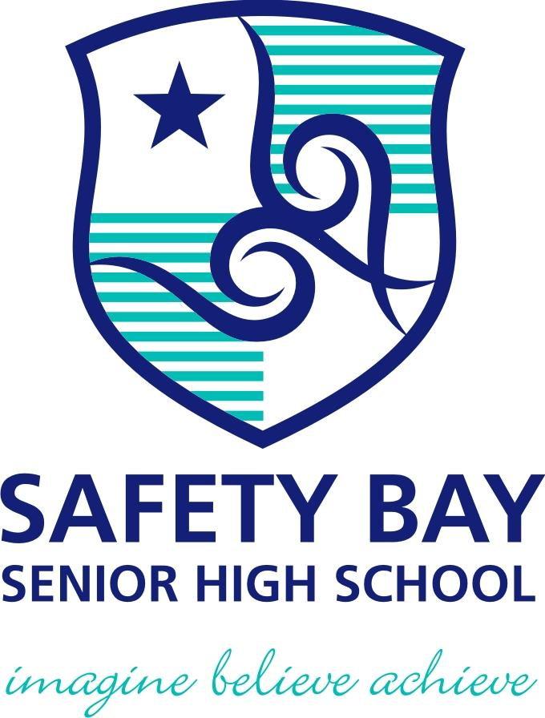 |  | Safety Bay Senior High School  Assessment Outline Report: 2022  Assessment Outline: ATCHE – 2022  Course: Chemistry  Unit: ATCHE
Assessment Type | Weightings  (syllabus) |  | % Weight | When | Task Description and Content |  | Max Score
Science inquiry | 20.0%  (20%) |  | 7 | Term 1, Week 8 | 3  Practical Test #1:  Volumetric Analysis |  | 100.0
 |  |  | 6 | Term 2, Week 1 | 5  Investigation #1:  Construction and analysis of electrochemical cells |  | 100.0
 |  |  | 7 | Term 3, Week 1 | 8  Practical Test #2:  Empirical Formulae |  | 100.0
Extended response | 10.0%  (10%) |  | 5 | Term 2, Week 2 | 4  Extended Response #1:  Principles in use of electrochemical cells in society |  | 100.0
 |  |  | 5 | Term 3, Week 6 | 10  Extended Response #2:  Amino acids, proteins, polymers, soaps, detergents and alcohols |  | 100.0
Test | 20.0%  (20%) |  | 4 | Term 1, Week 4 | 1  Test #1:  Rates and Equilibrium |  | 100.0
 |  |  | 4 | Term 1, Week 9 | 2  Test #2:  Acids & Bases |  | 100.0
 |  |  | 4 | Term 2, Week 3 | 6  Test #3:  Reduction & Oxidation |  | 100.0
 |  |  | 4 | Term 3, Week 2 | 9  Test #4:  Organic Chemistry |  | 100.0
 |  |  | 4 | Term 3, Week 7 | 11  Test #5:  Chemical Synthesis/Polymers |  | 100.0
Examination | 50.0%  (50%) |  | 20 | Term 2, Week 5 | 7 (School Examination)  Semester 1 Examination  Unit 3 content only |  | 100.0
 |  |  | 30 | Term 3/4 Holidays | 12 (School Examination)  Semester 2 Examination  Unit 3 and 4 content (Mock WACE examination) |  | 100.0
Total |  |  | 100

